Paper Layout: 3cm left, all other sides 2cm.
header 0.8cm while footer 1 cm
Title Garamond 17pt, Capitalized Each Word
Dynamic Modeling of Three Links Robot Manipulator (Open Chain) with Spherical Wrist
Affiliations: Garamond 10pt
First Author¹, Second Author ^{2*}
Text Size: Arabic Typesetting 13pt single spacing, all numbers should be written in Arabic style NOT Indian.
Arabic Typesetting 13pt, Bold
Authors: Arabic Typesetting 13pt
Arabic Title: Arabic Typesetting 18pt.
Authors affiliations:  1) Department, University of, City-Country.  email@website.com  2*) Department, University of, City-Country.  email@website.com  Paper History:  Received: 2nd Oct. 20xx  Revised: 9th Dec. 20xx  Accepted: 30th Jan. 2 0xx | Abstract  Dynamic modeling of a robot manipulator is a central problem in an accurate robot control. In this paper; the dynamic equations of motion were derived by using Eular-Lagrange method for a six degree of freedom articulated robot manipulator based on the geometrical jacobian construction for each link and actuator. In addition, friction effects beside the end effector forces that act the environment are considered. A Matlab Simulink plant is developed to embrace the theoretical work and simulate the dynamic response for a designed nonlinear controller Proportional Derivative plus Gravity (PD+G), also a modified controller is applied to reject the disturbances and the internal friction effect where the settling errors were 3.57E-6, 2.09E-7, -3.63E-6, 8.84E-6, -5.39E-8 and -4.39E-5 (deg) for joints one to six respectively. The presented approach can be applicable to solve the dynamic problem of other n-link robot manipulators and achieve a suitable solution for tracking trajectories.  Authors: Garamond 12pt , Capitalized Each Word
 | Keywords: Forward Kinematic, Jacobian, Nonlinear Controller, ode45, Solid Works.
النمذجة الديناميكية لروبوت ذراع مناور ذو ثلاث روابط ( النوع المفتوح) مع معصم كروي
حسن محمد علوان ، زيد حكمت رشيد
الخلاصة:
التمثيل الديناميكي للذراع المناور تعتبر مشكلة مركزيه من اجل السيطرة الدقيقية. في هذا البحث , تم اشتقاق معادلات الحركة باستخدام طريقة الطاقة ( اويلر- لاكرانج) لذراع مناورة متكون ثلاث اربطه و معصم كروي (ست درجات حرية) بالاعتماد على الاشتقاق الهندسي للمصوفة الجاكوبيه لكل رابط و محرك. بالاضافة الى الاخذ بنظر الاعتبار تأثير عزوم الاحتكاك و اضافة القوى و العزوم المطلوبة في النهاية المؤثرة. وتم استخدام برنامج الماتلاب لحساب الاستجابة الديناميكية للمسيطر اللاخطي المصمم (تناسبي – اشتقاقي بالاضافة الى التعجيل الارضي ).كذلك تم تطبيق المسطر المحدث لرفض الاضطرابات و الاحتكاك و كانت الاخطاء3.57E-6, 2.09E-7, -3.63E-6, 8.84E-6, -5.39E-8 -4.39E-5 (درجة) للمفاصل ستة الى واحد تعاقبيا.المسار المقدم يمكن ان يحل ديناميكية اي اذرع مشابهه.

1. Introduction
The robot manipulator has a high nonlinearity in dynamics and many inner variable parameters that effect on the dynamic response such as the inertia, Coriolis and friction forces so the precise dynamic model of a robot is an important step to achieve high performance robot control [1]. J. kardos[2] presented a simplified dynamic model for a three degree of freedom (DOF) anthropomorphic robot based on Eular Lagrange method using Matlab Simulink by considering the concentration of the mass of each link into its center of gravity , while Wathik and Wael[3] presented the modeling and control of the LabVolt 5250 robot arm 5 DOF by assuming each link is a homogenous cylinder; H. AL-Qahtani et al [4] presented the dynamics and control of a robot having four links where the Eular Lagrange analysis is carried out for the dynamics modelling; H. Al-Dois et al [5] described an analyzing method of dynamic performance for serial robot manipulators where they presented a numerical example for PUMA 560 as an illustrative case also A. Izadbakhsh [6] presented an explicit dynamic model of PUMA 560 robot without any mathematical simplifications and compare numerically the dynamics errors of different inputs with the proposed model of B. Armstrong [7]; Y.D. Patel and P. M. George [8] were used the analytical calculations of Newton Eular analysis for joints torques and observed that around 3% variation compared to Eular Lagrange approaches using Matlab and Pro/engineer software.
In this work; a three links robot arm with spherical wrist (six DOF) is adopted as a case study as shown in Fig.1. The Forward kinematic is presented based on Danivat Hartenberg convention in order to get the positions and orientations vectors from the transformation matrices which are useful in geometrical jacobian construction where the jacobian is one of the most important tool for manipulator characterization in finding singularities[9], determining inverse algorithm, related the joint torques and applied forces, deriving equations of motion and designing operational control schemes[10]. Also the Eular Lagrange energy method is used to derive the equations of motions since it treats the robot as a whole by taking the total kinetic and potential energies of links and actuators to give a more compact and direct model which can be easily edited to add the friction and disturbance torques.
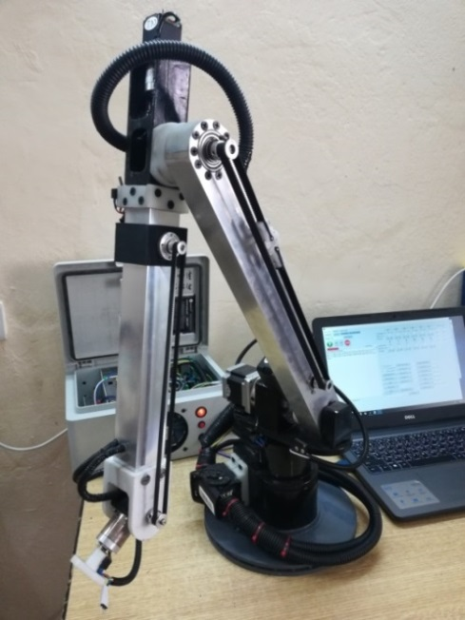
Figure (1): Three links robot manipulator 6 DOF

2. Forward Kinematics Modeling

Forward kinematics is the transformation between joint space and the cartesian space to solve the position and orientation of the robot end effector. Denavit Hartenberg (DH) convention computes the forward kinematic by attaching a coordinate frame system at each joint and specifying the four parameter of DH: αi-1, ai-1, θi and di where: [11]

ai : (link length) is the distance between zi-1 and zi axes along the xi axis.

αi: ( link twist) is the required rotation of zi-1 to zi axes about the xi axis.

di : (joint offset) is the distance between xi-1 and xi axes along the zi-1 axis.

θi : ( joint angle) is the required rotation of xi-1 to xi axes about the zi-1axis.

The transformation matrix of frame {i} relative to previous frame {i-1} is:

...(1)

And the transformation matrix of nth coordinate frame to base coordinate frame is:

...(2)

The first (3x3) matrix represents rotation matrix of frame {i} relative to frame {i-1} and the fourth column represents the origin of the frame {i} position in frame {i-1}. DH parameters of the robot manipulator are defined according to the assigned frames that shown in Fig.2 and they are listed in Table 1[12].

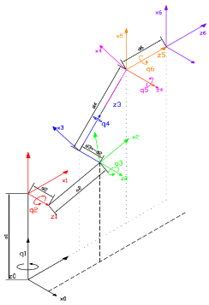

Figure (2): The Attached Coordinate Frame Systems.

Table (1): DH Parameters of the Robot Manipulator.
i | a_{i} (mm) | α_{i} (deg) | d_{i}(mm) | Ѳ_{i}
1 | 0 | 90 | 201 | q₁
2 | 390 | 0 | 65 | q₂
3 | 0 | 90 | -65 | q₃
4 | 0 | -90 | 380 | q₄
5 | 0 | 90 | 0 | q₅
6 | 0 | 0 | 81 | q₆

3. Kinematic Jacobian
Jacobian gives the relationship between the joints velocities and the corresponding end effector linear and angular velocities. The end effector linear and angular velocities can be defined as:
Where:
v_{e} : (3x1) matrix represents the end effector linear velocity in cartesian space.
ω_{e} : (3x1) matrix represents the end effector angular velocity in cartesian space.
J_{p} : (3xn) jacobian matrix relates the end effector linear velocity to joints velocities.
J_{o} : (3xn) jacobian matrix relates the end effector angular velocity to joints velocities.
The geometry i^{th} column of jacobian matrix for revolute joint is: [13]
Where:
- z_{i-1} : unit vector in z-direction is given by third column of the rotation matrix .
- p_{e :} end effector position vector is given by the first three elements of fourth column of transformation matrix .
- p_{i-1 :} is given by the first three elements of the fourth column of transformation matrix .

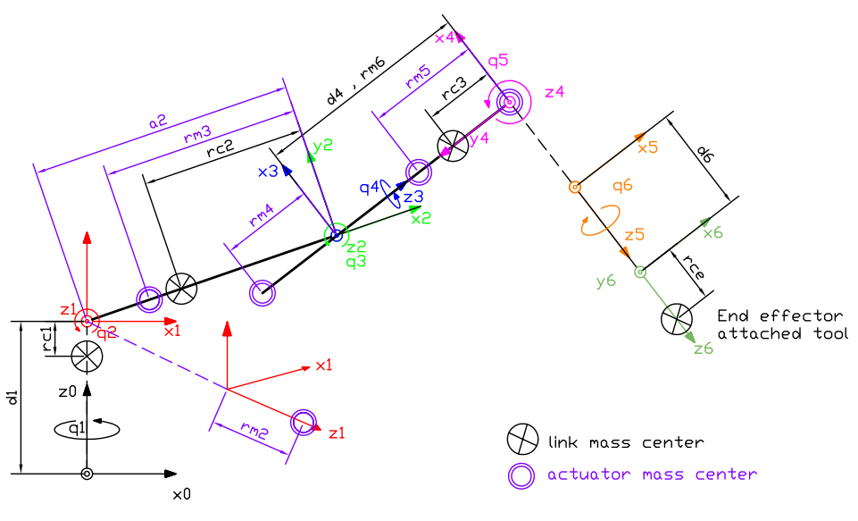
Figure (3): Schematic diagram of dynamic model

Note 1: All Figures, Tables… etc. must be written within the paper paragraphs.

Note 2: All Figure captions must be written after the figure. However, table caption must be written before the table.

5. Results and discussions:
A Matlab Simulink system is built to embrace the theoretical work as shown in Fig.7.
Figures 8&9 show the joints trajectory for the manipulator collapsing under gravity because the applied torques set to zero and continuous swing due to zero friction (ideal joint) also the 1st joint rotates due to coriolis effect in one direction because the links center masses right a side of base center.

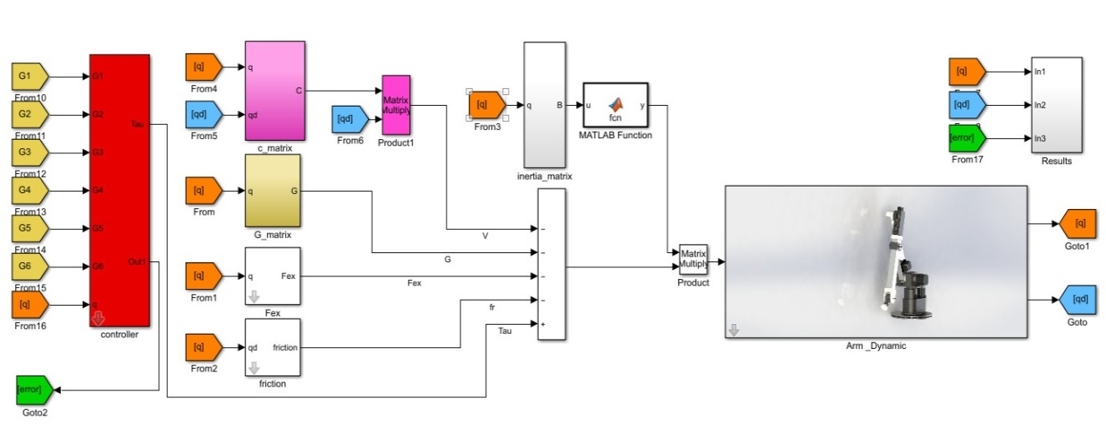
Figure (7): Matlab Simulink system

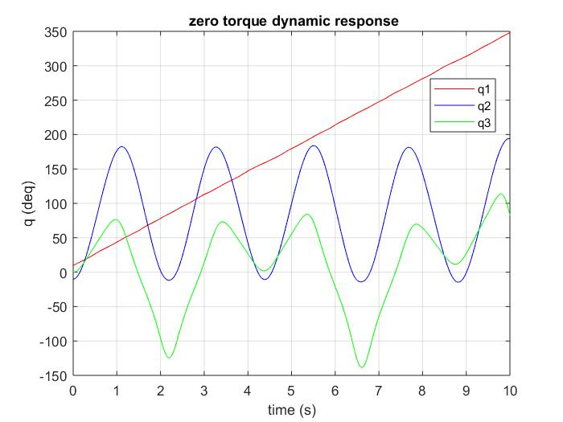
Figure (8): Joints angles of free response by ode45
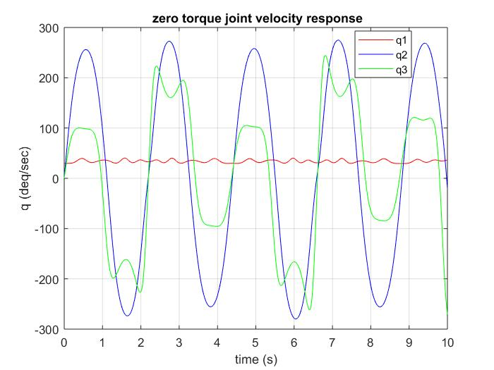
Figure (9): Joints rate angles of free response

7. References:
Note 3: References should be written using IEEE 2006 Reference Order style.
Garamond 10pt font should be used for the refs.
In case of adding refs manually, you can find IEEE references style here.

